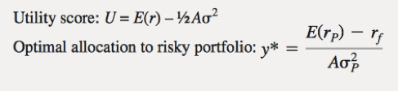 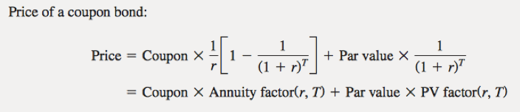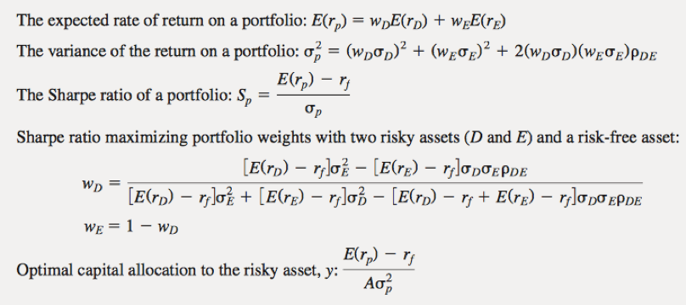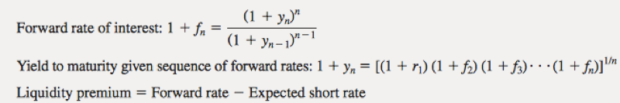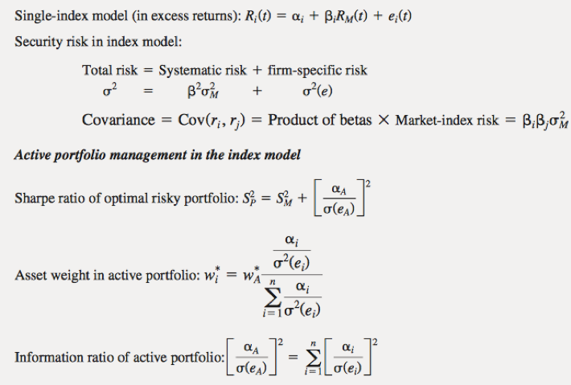

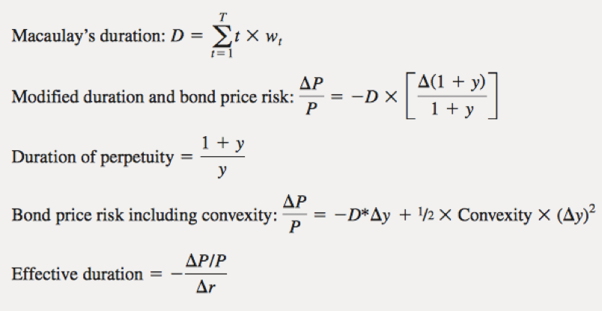

* sample average = µˆ = 1 N N ∑ i=1 xi
* sample variance = s 2 = 1 N −1 N ∑ i=1 (xi − µˆ) 2
* sample covariance = σˆxy = 1 N −1 N ∑ i=1 [(xi − µˆx ) (yi − µˆy )]
* If two variables are independent, their covariance is 0 (NOT vice versa). For jointly normal variables, covariance is the complete description of dependence Correlation is a rescaled covaraince that is unitless (has no scale). It ranges from -1 to 1 ρx,y ≡ Corr[X, Y ] ≡ σx,y σxσy
* Var[a1 +X] = σ 2 x Var[b1X +b2Y ] = b 2 1σ 2 x +b 2 2σ 2 y +2b1b2σx,y Cov[a1 +b1X, a2 +b2Y ] = b1b2σx,y
* U[rp] = E[rp]− 1/2 \*γσ2[rp] γ measures the investor’s risk aversion
* A risk-free bond which pays $1000 three years from now is priced at $863.84. What is the three year zero-coupon interest rate? yn = (1000/864.84) 1/3 −1 = 5%
* With two assets, portfolio expected return is given by:

E[rp] = w·E[rA] + (1−w)·E[rB ]

w ≡ w p A and w p B = 1−w p A

* use to find highest possible sharpe ratio WMVEB = E[˜rB ]σ2A −E[˜rA]σAB

E[˜rB]σ2A + E[˜rA]σ2B − (E[˜rA] + E[˜rB ])σAB

* cov[ri ,rj] = cov[βim+ei , βjm+ej ] = βiβjσ2m
* Sharpe=reward-to-variability ratio